**Hello World RESTful Web Service**

HelloController.java:

**package** com.cognizant.spring_learn.controller;

**import** org.springframework.web.bind.annotation.GetMapping;

**import** org.springframework.web.bind.annotation.RestController;

@RestController

**public** **class** HelloController

{

@GetMapping("/hello")

**public** String sayHello()

{

**return** "Hello World!!";

}

}

URL http://localhost:8083/hello

"Headers" tab to view the HTTP header details received:

Project Structure:

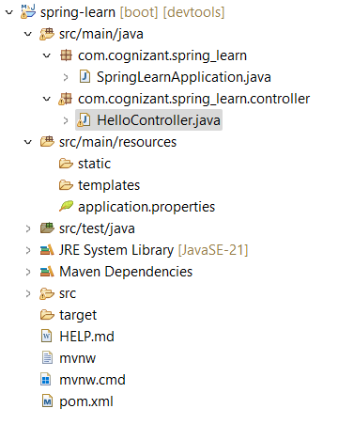

**REST - Country Web Service**

@RequestMapping("/country")

**public** Country getCountryIndia()

{

ApplicationContext context = **new** ClassPathXmlApplicationContext("country.xml");

Country country = (Country) context.getBean("country", Country.**class**);

**return** country;

}

**country.xml:**

<?xml version=*"1.0"* encoding=*"UTF-8"*?>

<beans xmlns=*"http://www.springframework.org/schema/beans"*

xmlns:xsi=*"http://www.w3.org/2001/XMLSchema-instance"*

xsi:schemaLocation=*"*

*http://www.springframework.org/schema/beans*

*http://www.springframework.org/schema/beans/spring-beans.xsd"*>

<bean id=*"country"* class=*"com.cognizant.spring_learn.model.Country"*>

<property name=*"code"* value=*"IN"*/>

<property name=*"name"* value=*"India"*/>

</bean>

</beans>

**Project Structure:**

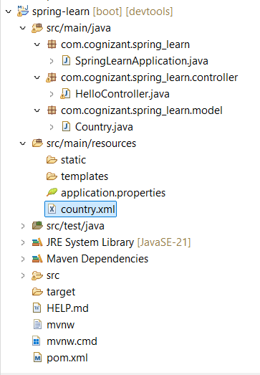

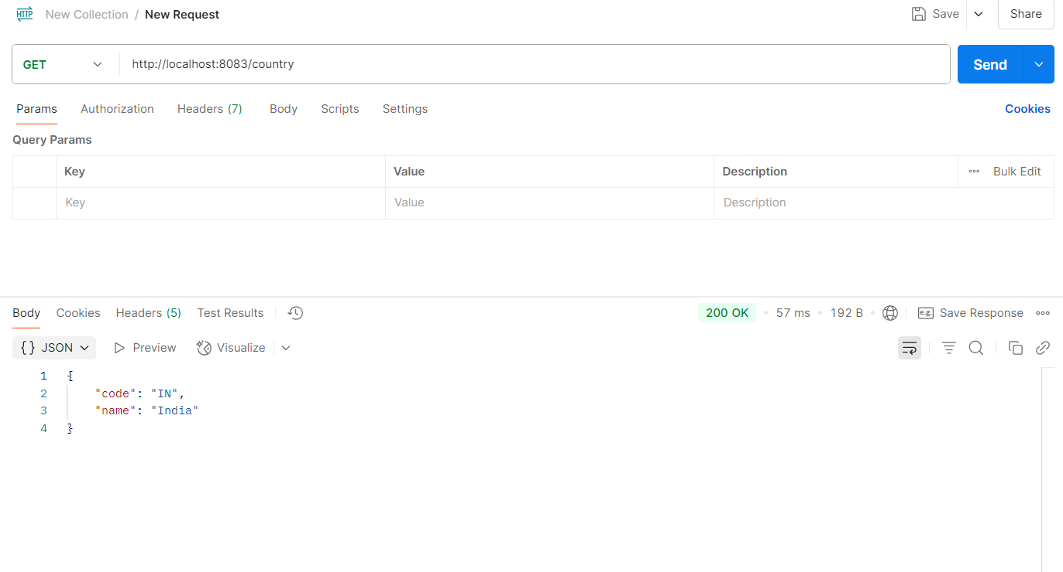

In postman, “Headers" tab to view the HTTP header details received:

In network tab of developer tools , the HTTP header details received:

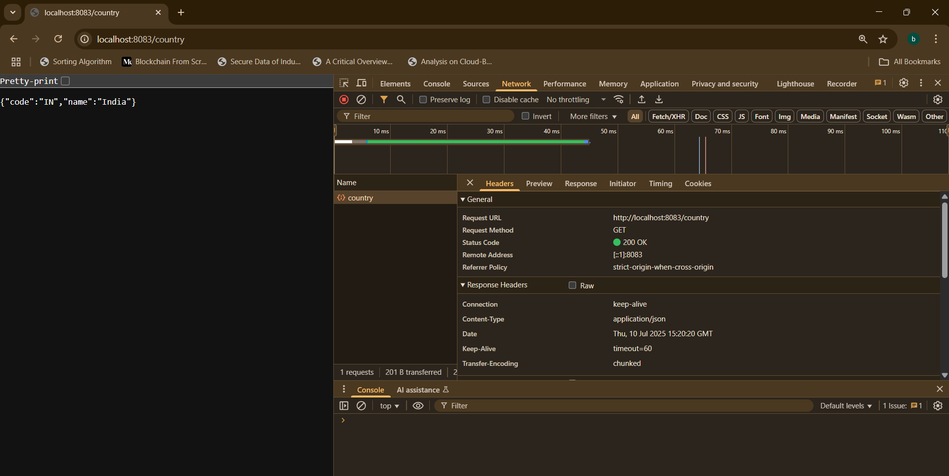

**REST - Get country based on country code**

Project structure:

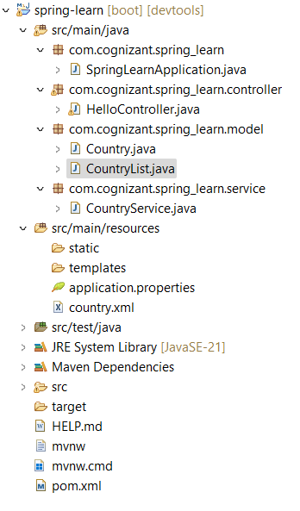

Method in Controller :

@GetMapping("/countries/{code}")

**public** Country getCountry(@PathVariable String code)

{

**return** countryService.getCountry(code);

}

Service Implementation:

**package** com.cognizant.spring_learn.service;

**import** java.util.List;

**import** org.springframework.beans.factory.annotation.Autowired;

**import** org.springframework.stereotype.Service;

**import** com.cognizant.spring_learn.model.Country;

**import** com.cognizant.spring_learn.model.CountryList;

@Service

**public** **class** CountryService

{

@Autowired

**private** CountryList countryList;

**public** Country getCountry(String code) {

List<Country> countries = countryList.getCountries();

**if** (countries == **null**) {

**throw** **new** RuntimeException("Country list is not loaded.");

}

**for** (Country country : countries) {

**if** (country.getCode().equalsIgnoreCase(code)) {

**return** country;

}

}

**return** **null**;

}

}

Browser Output:

In postman:

